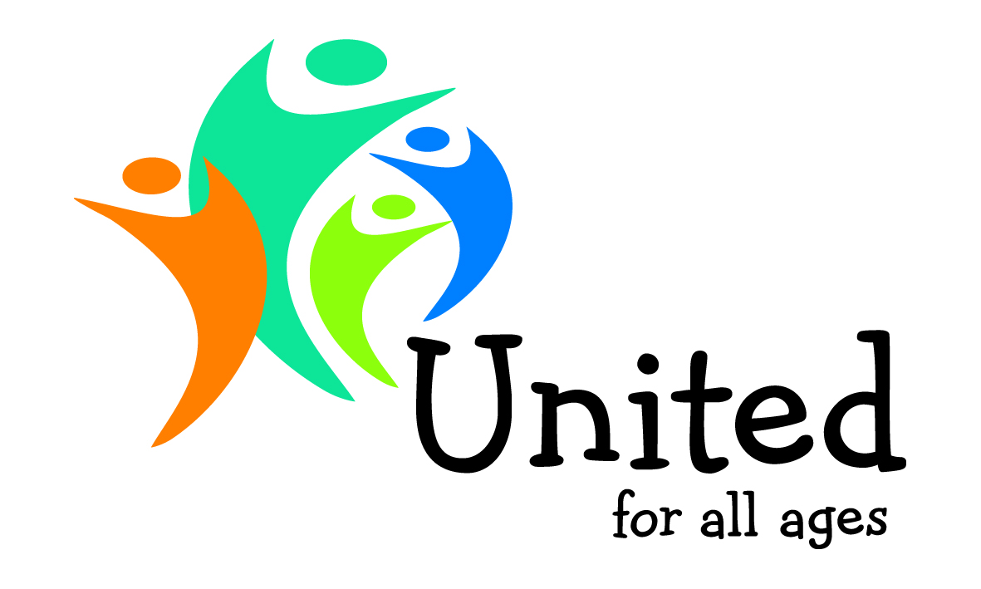
NEWS RELEASE Contact Stephen Burke 01692 650816/07714 334510
Embargoed to: 15.45 hours Tuesday 5 February 2013
AWARDS FOR ALL AGES WINNERS BRING OLDER AND YOUNGER PEOPLE TOGETHER TO TACKLE LONELINESS, CARE AND AGEISM
Three pioneering projects involving younger people in care settings for older people are winners of the annual Awards for All Ages run by social enterprise United for All Ages.
The Awards winners show how bringing older and younger people together can tackle big issues like improving care, reducing loneliness and challenging ageist stereotypes.
The winners will receive their Awards at the Older People’s Services conference in Westminster this afternoon (Tuesday 5 February).
The winning projects are:
- Magic Me, East London – ‘cocktails in care homes’ weekly evening parties

- The Peace Hospice, Watford – ‘creating memories’ conversations towards the end of life

- Learning for the Fourth Age – volunteers supporting learning for care home residents
Details of the winners are set out below in Notes to Editors.
Stephen Burke, director of United for All Ages, said: “The Awards show how action by and for people of all ages can tackle some of the big issues facing our country. The winners are all making a real difference. By bringing older and young people together in different ways, they are reducing loneliness, addressing ageism and improving care.
“These projects provide positive examples. They offer a win-win for older people living in care settings and for younger volunteers. Opening the doors of care homes and hospices to volunteers of all ages shows what can be done to boost quality of life for older residents.”

Notes to editors
For media enquiries, including attending the Older People’s Services conferences and Awards presentation and contact details and photos of the Awards for All Ages winners, please contact Stephen Burke on 01692 650816 or 07714 334510, or email: stephen.burke@unitedforallages.com
For more about the Older People’s Services conference, chaired by Stephen Burke, Director of United for All Ages, visit: http://www.neilstewartassociates.com/sh300/agenda.php

AWARDS FOR ALL AGES – MORE ABOUT THE WINNERS

Magic Me, East London – ‘cocktails in care homes’ weekly evening parties
Cocktails in Care Homes grew out of conversations with care home residents. They identified a need for evening adult activity. It started as a pilot in 2010. Now thanks to a pool of 100 volunteers, Magic Me hosts weekly evening parties across East London for residents, relatives, friends and carers. Magic Me provides lighting, decorations, music and a range of drinks to set a party mood and encourage conversation. Residents are canvassed about their favourite music and drinks to ensure they genuinely enjoy and look forward to parties. The project is growing to reach more people in isolation.
Cocktail volunteers are the only visitors some residents get. Residents who don’t engage in other activities come to cocktail parties. Residents enjoy anticipating parties, something to get dressed up for, and post-party gossip the next day. Staff, families and volunteers note increased communication by some residents with dementia. Parties offer residents space and structures to get to know each other. Volunteers facilitate conversation and interaction. Care staff get to know residents as people, enjoying quality time together as equals. Volunteers enjoy volunteering in a group setting, where they feel supported to do difficult though enjoyable work and can socialise with a purpose. http://www.magicme.co.uk/

The Peace Hospice, Watford – ‘creating memories’ conversations towards the end of life
‘Creating memories’ was an intergenerational project involving twelve students and four patients that ran over four weeks. The aim was to produce a mixed media memory picture about the patients’ lives. The patients and students worked together using spidergrams, a simple method of organising information to explore the patient’s life. They used photographs of objects, pictures and memorabilia collected by patients. To celebrate the project, they had an exhibition and tea party where patients’ families, the students and members of the community visited the hospice.
The project broke down barriers between the old and the young – they shared, compared and created new memories together. Assumptions about young people were challenged; assumptions about older generations and illness were challenged. The project confronted beliefs about disability – a patient with MND communicated through his iPad. The hospice’s patients are moving towards the end of their lives and the conversations about end of life occurred naturally with the young people. The exhibition gave the patients a new voice; their pictures demonstrated to visitors how rich their lives had been and how valued they felt. http://www.peacehospice.co.uk/

Learning for the Fourth Age – volunteers supporting learning for care home residents
L4A provides one-to-one learning opportunities to older people living in care settings using a network of younger volunteers. Learning boosts confidence and sociability for everyone and creates new relationships between generations. It has also been linked to reduced medication for older people and increased job prospects for older people.
L4A’s work busts stereotypes and breaks down barriers between generations. It tackles two huge social ills: youth unemployment and the ailing care system to create a large impact with minimum costs and benefits for everyone involved. The understanding created by mutual learning is key to an intergenerational society. http://www.l4a.org.uk/

The 13 finalists for the Awards for All Ages run by United for All Ages were:
- Magic Me, East London – ‘cocktails in care homes’ weekly evening parties
- Friends of the Elderly – ‘What does Christmas mean to you?’ campaign on loneliness
- Homeshare East Sussex – matching older people with a spare room with younger people
- The Peace Hospice, Watford – ‘creating memories’ conversations towards the end of life
- Intergen – older people working with young people in schools
- Ransackers Association – higher education opportunities for people aged 55+
- Community Transport – minibus transport giving people of all ages new opportunities
- LJWB, Leeds – caring for 2000 people a week, with social support from younger families
- The Children’s Society, Greenwich – primary school curriculum involving older people
- Haverstock School, Camden – Saturday seniors’ sessions run by students
- Holly Lodge Community Centre, Camden – bringing local people of all ages together
- Learning for the Fourth Age – volunteers supporting learning for care home residents
- Linking Generations Northern Ireland – supporting projects bringing generations together

United for All Ages is a social enterprise that aims to build a stronger Britain by bringing younger and older people together through shared sites, shared caring and shared interests. Launched in 2010, United is working with councils, charities, universities and companies to make ‘Britain for all ages’ a reality. United for All Ages was set up by Stephen Burke and Denise Burke who both have substantial experience in childcare and eldercare. Stephen was chief executive of two national charities, Daycare Trust and Counsel and Care, and was cabinet member for social services and vice-chair of a primary care trust in a London borough. Denise led on childcare for Peterborough city council and headed up youth and childcare for the Mayor of London as well as being chair of BBC Children in Need for London and the South East. Stephen is now co-chair of Grandparents Plus and trustee of several other national and local charities. United for All Ages has focused on developing ‘care for all ages’ and ‘centres for all ages’. Policy papers from United for All Ages, including United or divided?, Investing in the future, Ten Dilnot Flaws and The Childcare Funding Crisis, can be downloaded from www.unitedforallages.com
In 2012 United for All Ages and My Family Care launched www.goodcareguide.co.uk the only site where families can find, rate and review childcare and eldercare.

